1. Select all columns from the "employees" table where the salary is greater than 50000.

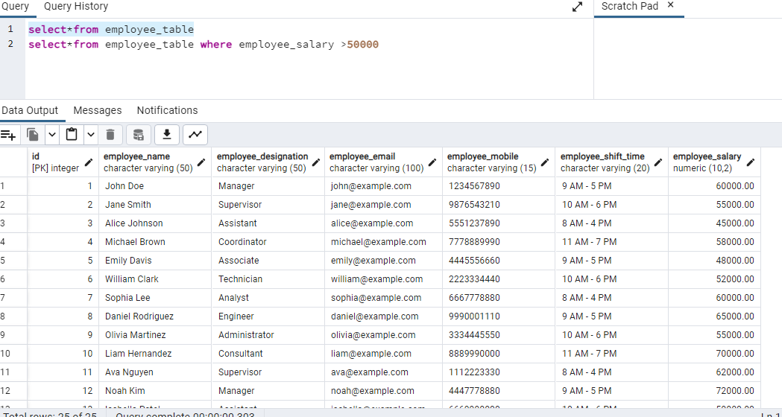



1. Update the "products" table to set the price to 10% higher for all products in the "electronics" category.

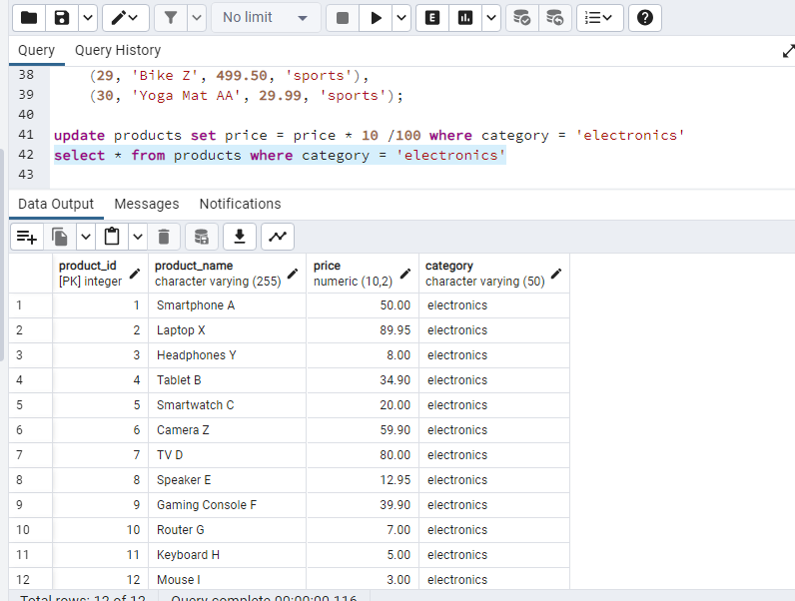

1. Insert a new record into the "customers" table with the following details: (ID: 101, Name: 'John Doe', Email: 'john.doe@example.com').

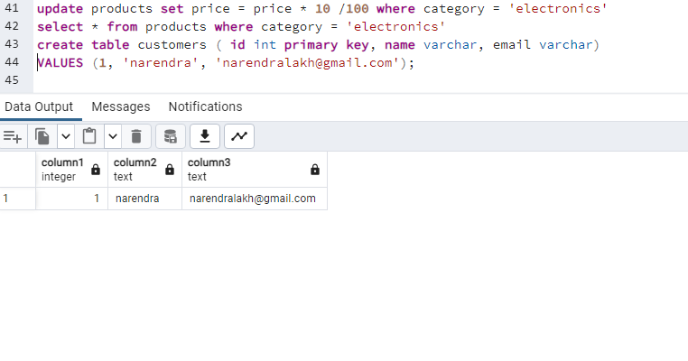

1. Delete all records from the "orders" table where the order status is 'Cancelled'.

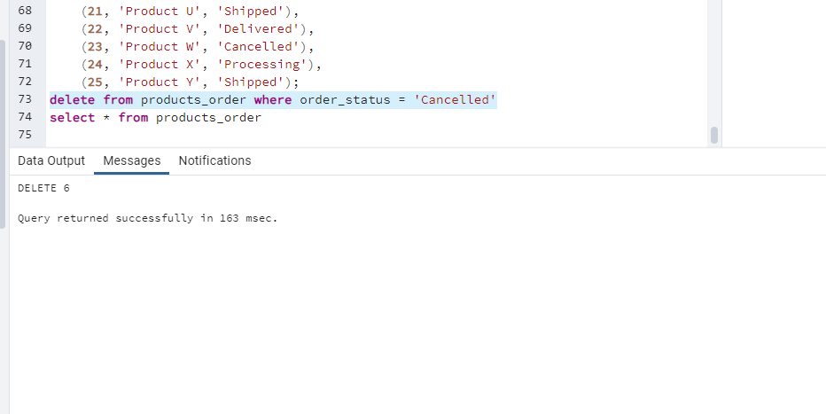

1. Select the distinct values of the "category" column from the "products" table.

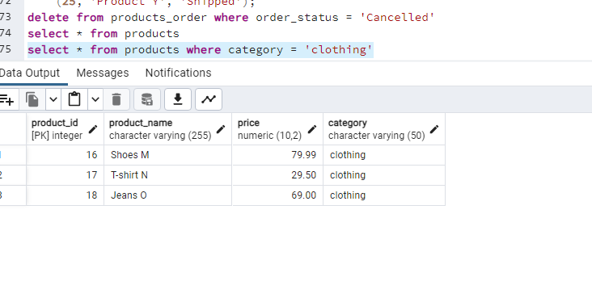

1. Update the "employees" table to increase the salary by 5% for all employees in the 'Sales' department.

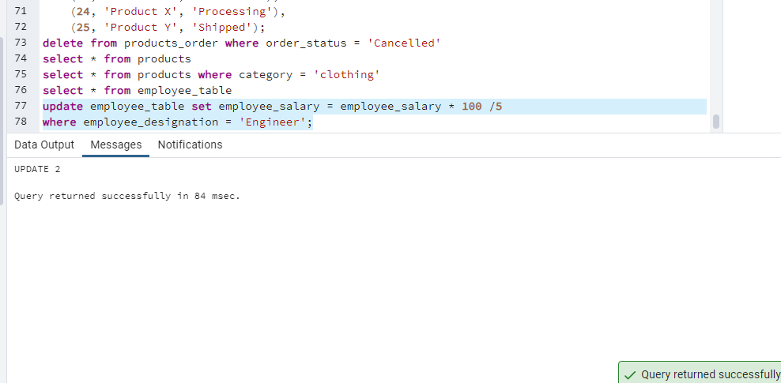

1. Insert a new record into the "suppliers" table with the following details: (ID: 201, Name: 'ABC Electronics', Location: 'New York').

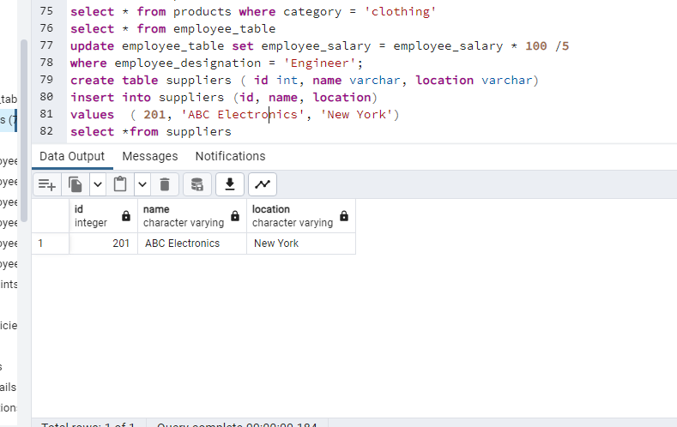

1. Delete all records from the "customers" table where the last purchase was made before 2023-01-01.

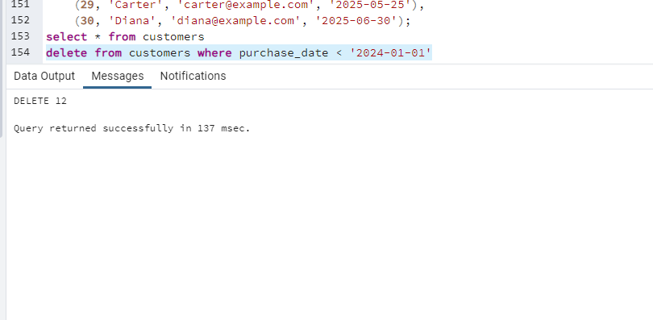

1. Select the average salary from the "employees" table.

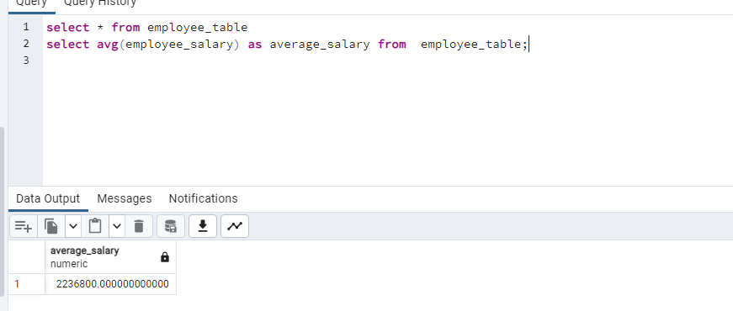

1. Update the "products" table to set the quantity in stock to 0 for all products that are out of stock.

`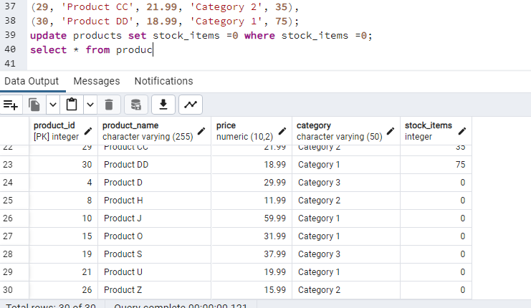

1. Insert a new record into the "orders" table with the following details: (OrderID: 1001, CustomerID: 105, ProductID: 203, Quantity: 5, OrderDate: '2024-01-06').

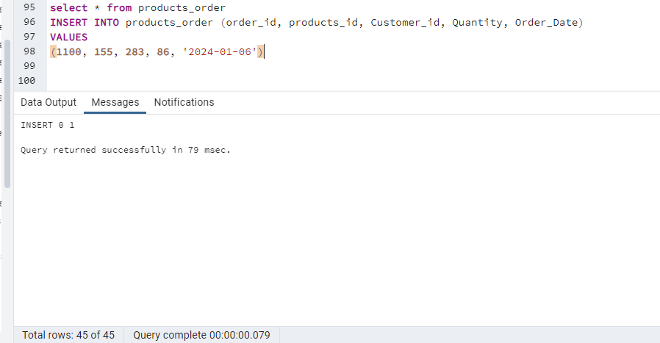

1. Delete duplicate records from the "employees" table based on the "email" column.

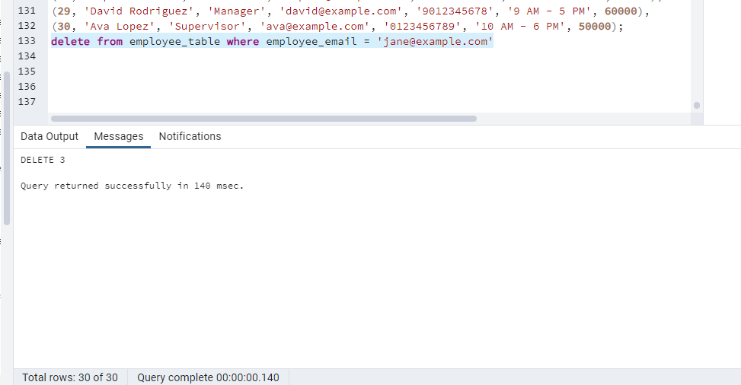

1. Select the product with the highest price from the "products" table.

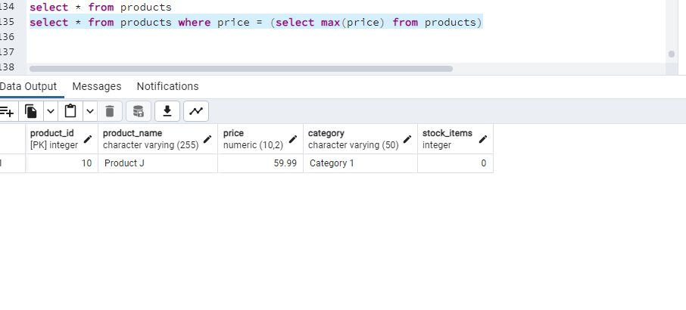

1. Update the "customers" table to set the discount to 15% for all customers who have made more than 10 purchases.

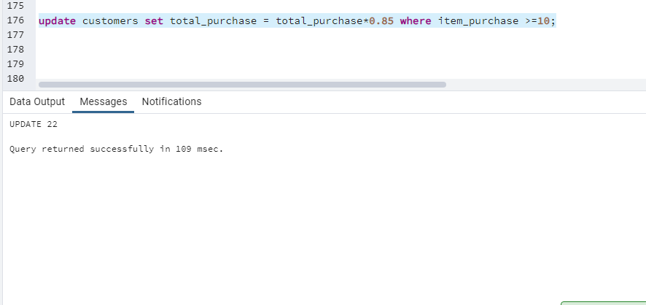

1. Insert a new record into the "categories" table with the following details: (CategoryID: 301, CategoryName: 'Home and Garden').

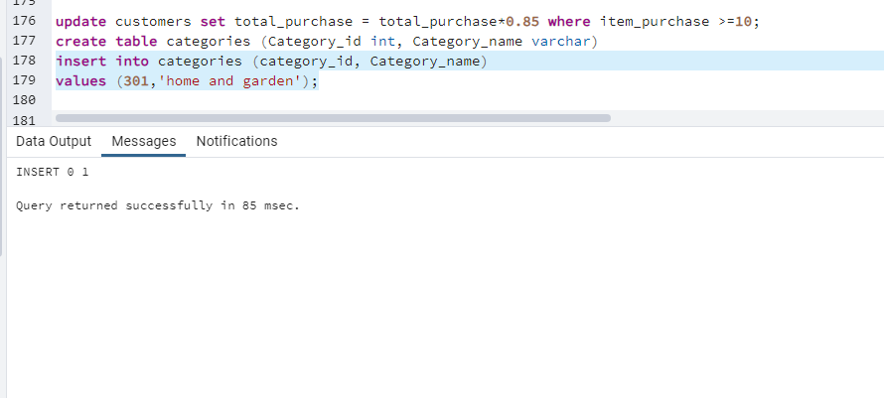

1. Delete all records from the "orders" table where the order date is older than 90 days.

